**PROJECT REPORT**

**on**

**Brain tumor detection**

**(CSE VI Semester Mini project PCS-604)**

**2020-2021**



**Submitted to: Submitted by:**

Mr. Inderjeet Kumar Mr. Sachin Sati

(CC-CSE-C-VI-Sem)Roll. No.: 1018568

CSE-C-VI-Sem

Session: 2020-2021

**Guided by:**

Mr. Mr. Amit Gupta

And Mr. Navin Garg

(Resource Person)

**DEPARTMENT OF COMPUTER SCIENCE AND INFORMATION TECHNOLOGY**

**GRAPHIC ERA HILL UNVERSITY, DEHRADUN**

**CERTIFICATE**

### Certified that Mr. Sachin Sati (Roll No.- 1018568) has developed mini project on “Brain Tumor Detectoion using image segmentation” for the CS Vi Semester Mini Project Lab (PCS-604) in Graphic Era Hill University, Dehradun. The project carried out by Students is their own work as best of my knowledge.

Date:

(Mr. Inderjeet Kumar)

**Project Co-ordinator**

**CC-CSE-C-VI-Sem**

(CSE Department)

GEHU Dehradun

(Mr. Amit Gupta and Navin Garg)

**Project Guide**

Resource Person

(CSE Department)

GEHU Dehradun

**ACKNOWLEDGMENT**

We would like to express our gratitude to The Almighty Shiva Baba, the most Beneficent and the most Merciful, for completion of project.

We wish to thank our parents for their continuing support and encouragement. We also wish to thank them for providing us with the opportunity to reach this far in our studies.

We would like to thank particularly our project Co-ordinator Mr. Inderjeet Kumar and our Project Guide Mr. Amit Gupta and Navin Garg for his patience, support and encouragement throughout the completion of this project and having faith in us.

We also acknowledge to teachers like Mr Amit Gupta and Mr. Navin GARG who help us in developing the project.

At last but not the least We greatly indebted to all other persons who directly or indirectly helped us during this work.

**Mr. Sachin Sati**

**Roll No.- 1018568**

**CSE-C-VI-Sem**

**Session: 2020-2021**

**GEHU, Dehradun**

**TABLE OF CONTENTS**

Abstract 1

* 1. INTRODUCTION 1,2
  2. Problem Statement [ Requirement of Project ] 2
     1. Hardware Requirement **2**
     2. Software Requirement 3
  3. Terminology Used 4
     1. Image Processing 4
     2. Neural Network 4
  4. What is Convolutional Neural Networks ? 5
  5. How Do Convolutional Neural Networks Work? 5
     1. Convolutional 6
     2. ReLu Layer 7
     3. Pooling 7,8
     4. Fully Connected Layer 8
  6. ALGORITHM 9
  7. SNAPSHOT OF PROJECT 9
     1. Output of Project 9
     2. Variable Explorer 10
     3. Graph Plotted 10
  8. CONCLUSION 11
  9. **REFERENCE 11,12**

## Abstract

Brain tumor identification is really challenging task in early stages of life. But now it became advanced with various machine learning algorithms. Now a day’s issue of brain tumor automatic identification is of great interest. In Order to detect the brain tumor of a patient we consider the data of patients like MRI images of a patient’s brain. Here our problem is to identify whether tumor is present in patients’ brain or not. It is very important to detect the tumors at starting level for a healthy life of a patient. There are many literatures on detecting these kinds of brain tumors and improving the detection accuracies. In this paper, we Estimate the brain tumor severity using Convolutional Neural Network algorithm which gives us accurate results.

* 1. **Introduction**

Tumor is the unusual growth of the tissues. A brain tumor is a quantity of unnecessary cells growing in the brain or central spine canal. It is an unrestrained progress of cancer cells in any portion of the body. Tumors are of different forms and have different features and different treatments. Presently, brain tumors are categorized as primary brain tumors and Metastatic brain tumors. The earlier arise in the brain and incline to stay in the brain, the later begin as a cancer in different places in the body and increasing to the brain part. Brain tumor segmentation is one of the critical techniques in careful and treatment planning. Brain tumor separation using MRI has been an extreme exploration area. Brain tumors have various dimensions and shapes and appear at different locations. Varying amount of tumors in brain magnetic resonance images (MRI) makes the automatic division of tumors enormously stimulating. There are various techniques which have been proposed to segment tumors on magnetic resonance images. Texture is one of most standard characteristic for image classification and retrieval. Texture segmentation is done using GLCM (Gray-Level Co- occurrence Matrix). From the MRI images of brain, the optimum texture characteristics of brain tumor are take out by using GLCM. Today, tools and techniques to evaluate tumors and their behavior are becoming more predominant. Clearly, determinations over the past century have generated real improvements. However, we have also diagnosis tools. Even if we have yet to cure brain tumors, few forward steps have to be followed on the way to reach the ultimate goal; more and more researchers have to be done which will be helpful to those who are suffering with brain tumors.

MRI Images are widely used for high quality imaging mostly in brain scanning images because brain tumors are easily tracked by these images. MRI provides a digital representation of tissue characteristics that can be obtained in any tissue plane. MRI Scanner produced images are sliced, added advantage is slicing into both horizontal and vertical planes. These MRI Scanned images are useful in identifying and detecting and classifying the tumor parts of the brain easily. Now a day’s most of the present techniques are human experience interpretation for image evaluation which may result in false identification of brain tumor. Digital way of representing the images can make us detection clear when

compared to manual. From the complex medical images, Information is gained using the technique called Segmentation. Its main objective is to segment the image into various partitions for image classification, but the risk factors may include rarely. Magnetic resonance imaging (MRI) is the prime technique to diagnose brain tumors and monitor their treatment. Different MRI modalities of each patient are acquired and these images are interpreted by computer-based image analysis methods in order to handle the complexity as well as constraints on time and objectiveness. In this thesis, two major novel approaches for analysing tumor-bearing brain images in an automatic way are presented: Multi-modal tissue classification with integrated regularization can segment healthy and pathologic brain tissues including their sub-compartments to provide quantitative volumetric information. The method has been evaluated with good results on a large number of clinical and synthetic images. The fast run-time of the algorithm allows for an easy integration into the clinical work flow.

An extension has been proposed for integrated segmentation of longitudinal patient studies, which has been assessed on a small dataset from a multi-center clinical trial with promising results. Atlas-based segmentation with integrated tumor-growth modeling has been shown to be a suitable means for segmenting the healthy brain structures surrounding the tumor. Tumor-growth modeling offers a way to cope with the missing tumor prior in the atlas during registration. To this end, two different tumor-growth models have been compared. While a simplistic tumor growth model offered advantages in computation speed, a more sophisticated multi-scale tumor growth model showed better potential to provide a more realistic and meaningful prior for atlas-based segmentation.

Both approaches have been combined into a generic framework for analyzing tumor-bearing brain images, which makes use of all the image information generally available in clinics. This segmentation framework paves the way for better diagnosis, treatment planning and monitoring in radiotherapy and neurosurgery of brain tumors.

## Problem Statement [ Requirement of Project ]

Under this project, “Brain Tumor Detection”, the main aim is to detect the MRI image of brain and identify it whether it is suffering from tumor or not .

### Hardware Requirement

The complete experimentation has been performed at Acer Predator PH315-52.

The specification of the system is given as Intel® Core™ i7-9750H CPU@ 2.60 GHz, 2.59 GHz, 16 Gigabyte RAM, 1 Terabyte HDD,6 GB Graphics/NVIDIA Geforce GTX 1660 Ti.

### Software Requirement

* + - * **Anaconda:** Anaconda distribution comes with over 250 packages automatically installed, and over 7,500 additional open-source packages can be installed from [PyPI](https://en.wikipedia.org/wiki/Python_Package_Index) as well as the [conda](https://en.wikipedia.org/wiki/Conda_(package_manager)) package and virtual environment manager. It also includes a GUI, Anaconda Navigator, as a graphical alternative to the command line interface (CLI).



* + - * **Spyder:** Spyder, the Scientific Python Development Environment, is a free integrated development environment (IDE) . It includes editing, interactive testing, debugging, and introspection features.

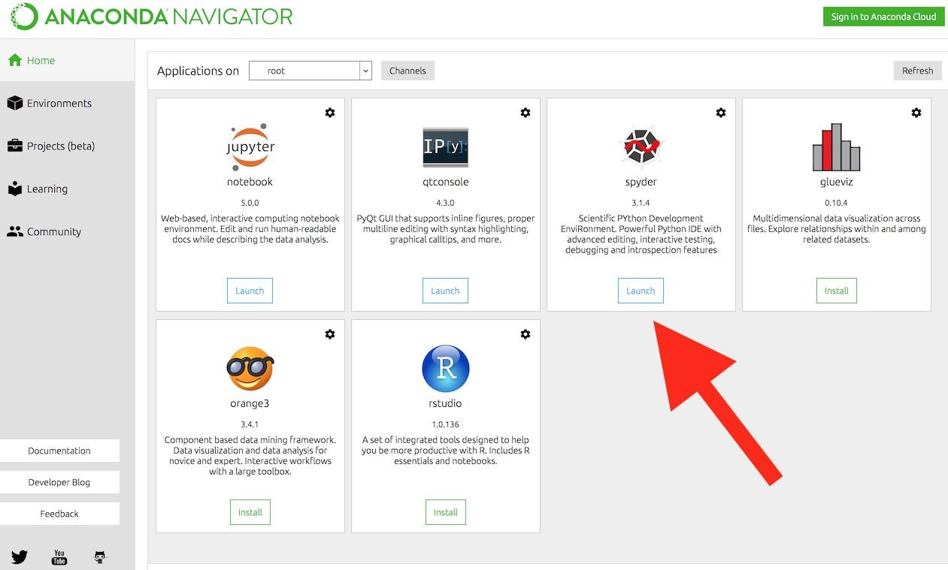

#### Other Software Requirement are:

* Python 3.5 or above.
* Numpy.
* Keras.
* Tensorflow.

## Terminology Used

For the completion of this work, a single dataset having x number of images in total were used and the dataset for downloaded from Kaggle.

The dataset contained images of two categories that is Tumor category and non Tumor category and the number of total images in both the categories were

150 and 98 respectively.

Further, the entire dataset was divided into two different classes that is training class and testing or validation class.

Further, in the train class, the total number of images of Tumor category and Non- tumor caterogy was 120 and 70 respectively whereas on the other hand in case of testing class, the total number of images of both the categories that is Tumor and Non- tumor, the number of images belonging to each category was 35 and 28

respectively.

### Image Processing

Image processing in machine learning is like applying multiple algorithms on an image and making the image work as per the model need and achieving the desired output.

### Neural Networks

On the other hand, Neural Network is like giving the model its own brain so that the model can work on this own. For model, Neural network is considered as

to be the most important component as like RBC and WBC in human bodies.

## What is Convolutional Neural Networks?

This Convolutional Neural Networks, like neural networks, are made up of neurons with learnable weights and biases. Each neuron receives several inputs, takes a weighted sum over them, pass it through an activation function and responds with an output.The whole network has a loss function and all the tips and tricks that we developed for neural networks still apply on Convolutional Neural Networks.Neural networks, as its name suggests, is a machine learning technique which is modeled after the brain structure. It comprises of a network of learning units called neurons.These neurons learn how to convert input signals (e.g. picture of a cat) into corresponding output signals (e.g. the label “cat”), forming the basis of automated recognition.Let’s take the example of automatic image recognition. The process of determining whether a picture contains a cat involves an activation function. If the picture resembles prior cat images the neurons have seen before, the label “cat” would be activated.Hence, the more labeled images the neurons are exposed to, the better it learns how to recognize other unlabelled images. We call this the process of training neurons

## How Do Convolutional Neural Networks Work?

Generally, A Convolutional neural network has three layers. And we understand each layer one by one with the help of an example of the classifier. With it can classify an image of an X and O. So, with the case, we will understand all four layers.

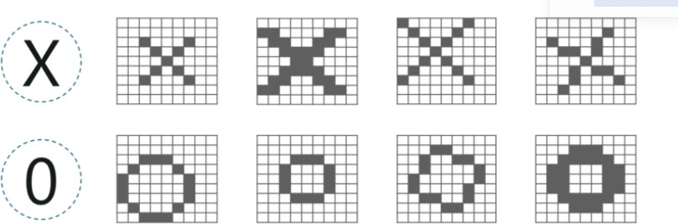

Convolutional Neural Networks have the following layers:-

### Convolutional

Convolution has the nice property of being translational invariant. Intuitively, this means that each convolution filter represents a feature of interest (e.g pixels in letters) and the Convolutional Neural Network algorithm learns which features comprise the resulting reference (i.e. alphabet).

We have 4 steps for convolution:

* + - * Line up the feature and the image
      * Multiply each image pixel by corresponding feature pixel
      * Add the values and find the sum
      * Divide the sum by the total number of pixels in the feature

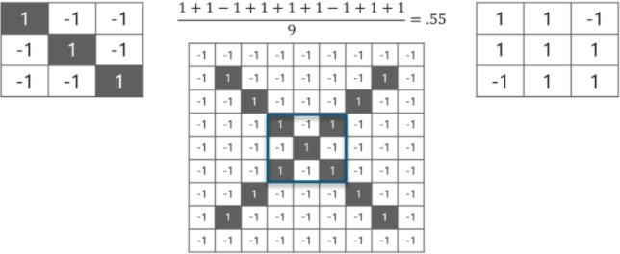

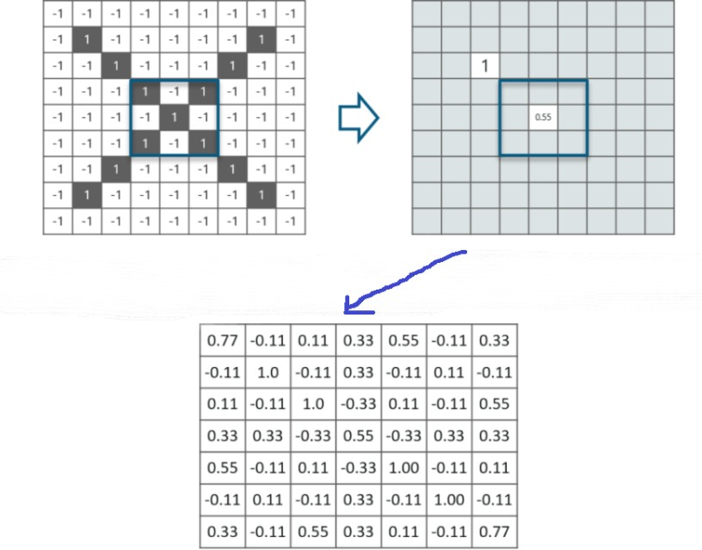

### ReLU Layer

In this layer, we remove every negative value from the filtered images and replaces them with zeros.

It is happening to avoid the values from adding up to zero.

Rectified Linear unit(ReLU) transform functions only activates a node if the input is above a certain quantity. While the data is below zero, the output is zero, but when the

information rises above a threshold. It has a linear relationship with the dependent variable.

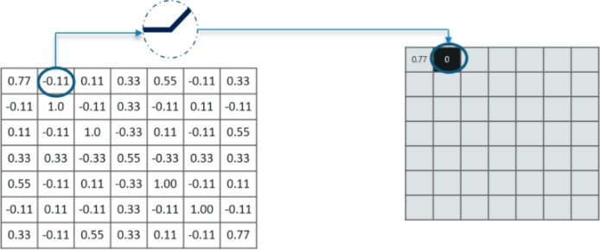

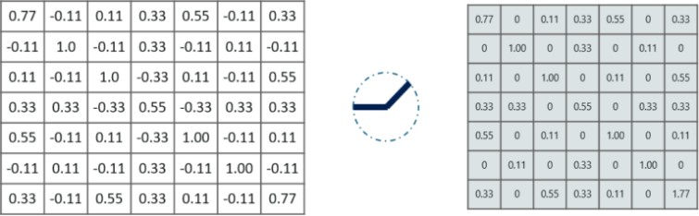

### Pooling

In this layer we shrink the image stack into a smaller size. Pooling is done after passing through the activation layer. We do this by implementing the following 4 steps:

* + - * Pick a window size (usually 2 or 3)
      * Pick a stride (usually 2)
      * Walk your window across your filtered images
      * From each window, take the maximum value

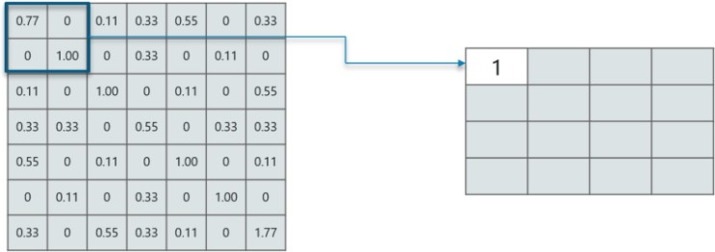

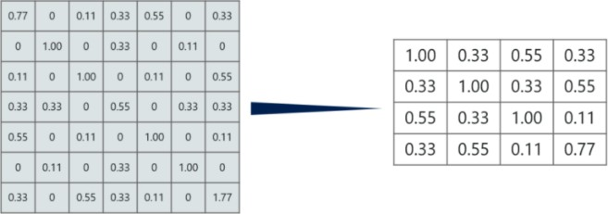

### Fully Connected Layer

At this point in time, we’re done training the network and we can begin to predict and check the working of the classifier.

## ALGORITHM

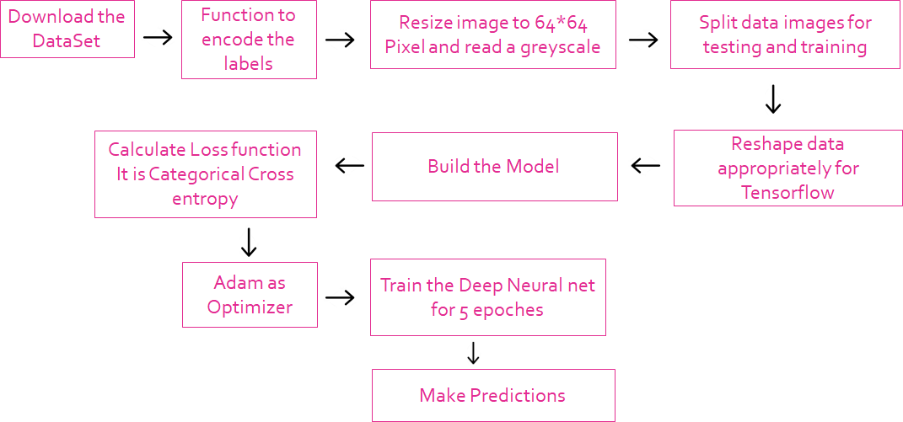

## SNAPSHOT OF PROJECT

### Output Of Project

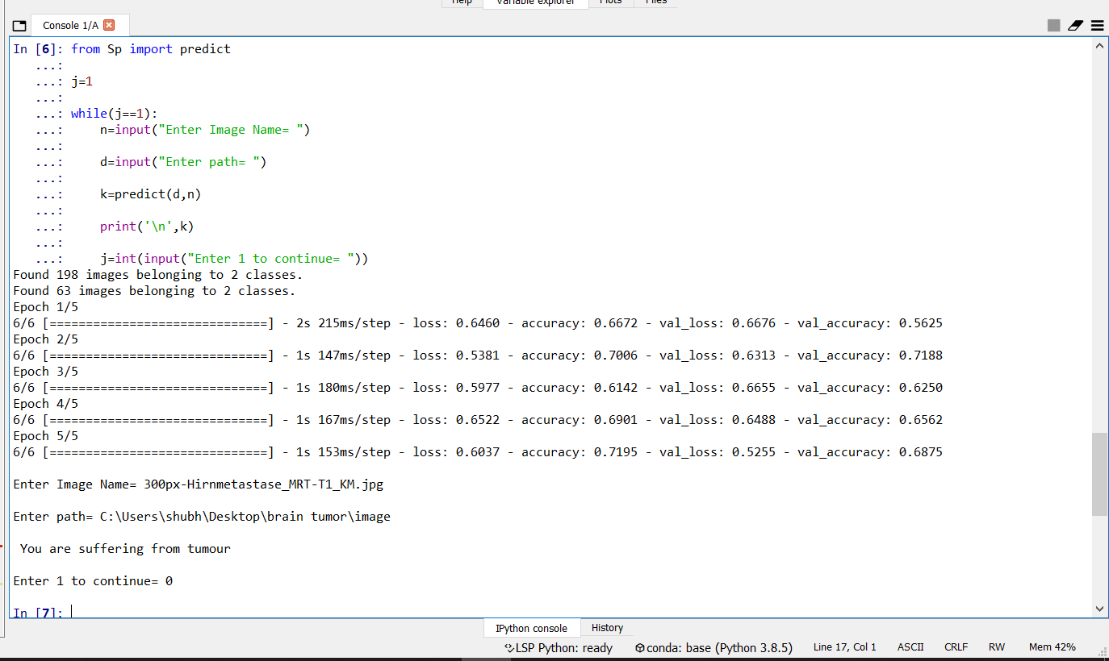

### Variable Explorer

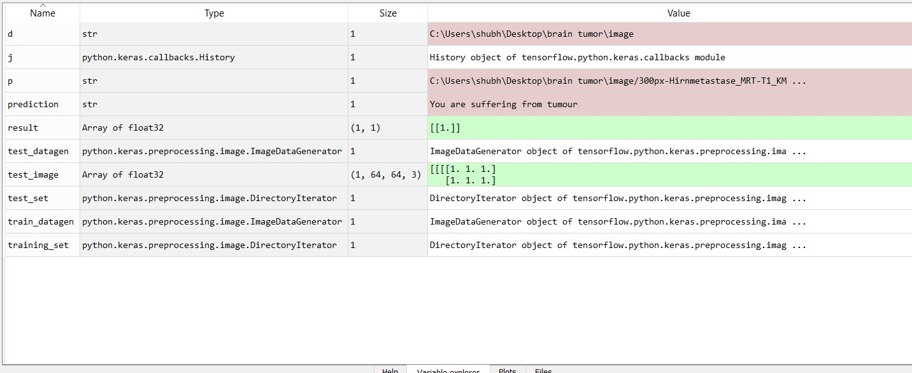

### Graph Plotted

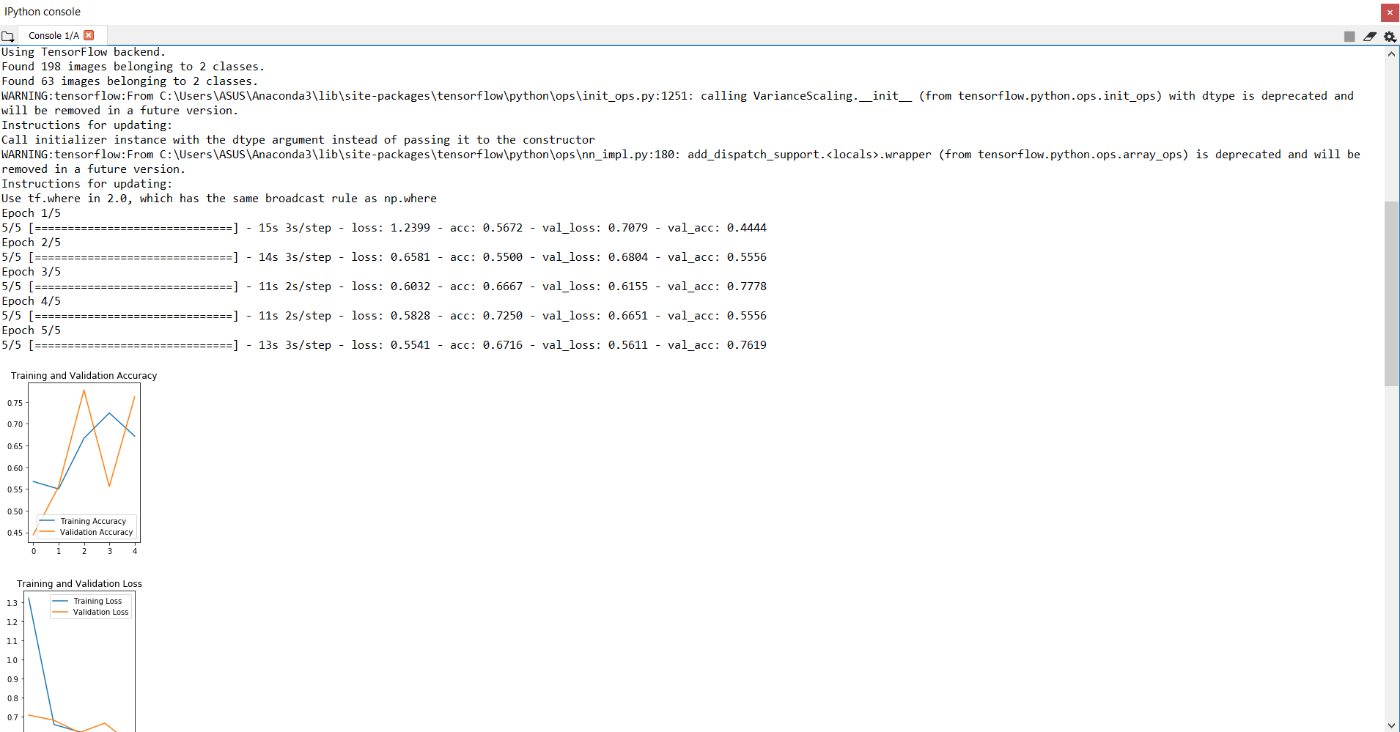

## Conclusion

The main goal of this work is to design efficient brain tumor classification with high accuracy, performance and low complexity. The complexity is low. But the computation time is high meanwhile accuracy is low. Further to improve the accuracy and to reduce the computation time, a convolution neural network-based classification is introduced in the proposed scheme. Also, the classification results are given as tumor or normal brain images. CNN is one of the deep learning methods, which contains sequence of feed forward layers.

Also, python language is used for implementation. Image net database is used for classification. It is one of the pre-trained models.

## REFERENCE

1. Mohsen H et al. Classification using Deep Learning Neural Networks for Brain Tumors. *Future Computing and Informatics.* 2017:1-4.
2. Bauer S. et al. Multi scale Modeling for Image Analysis of Brain Tumor Studies. *IEEE Transactions on Biomedical Engineering.* 2012;59:1. [CrossRef](https://doi.org/10.1109/TBME.2011.2163406)
3. Islam A. et al. Multi-fractal Texture Estimation for Detection and Segmentation of Brain Tumors. *IEEE.*
4. Huang M et al. Brain Tumor Segmentation Based on Local Independent Projection- based Classification. *IEEE Transactions on Biomedical Engineering.* 2013.IEEE.
5. Hamamci A et al. Tumor-Cut Segmentation of Brain Tumors on Contrast Enhanced MR Images for Radiosurgery Applications. *IEEE Transactions on Medical Imaging.* 2012*;*31:3.

[CrossRef](https://doi.org/10.1109/TMI.2011.2181857)

1. Bjoern H. M et al. The Multi modal Brain Tumor Image Segmentation Benchmark (BRATS). *IEEE Transactions on Medical Imaging.*
2. Liu J et al. A Survey of MRI-Based Brain Tumor Segmentation Methods. *TSINGHUA Science and Technology*. 2011;19;6.
3. Huda S et al. A Hybrid Feature Selection with Ensemble Classification for Imbalanced Healthcare Data A Case Study for Brain Tumor Diagnosis. *IEEE Access.* 2017*;*4.
4. Karuppathal and Palanisamy V. Fuzzy based automatic detection and classification approach for MRI-brain tumor. *ARPN Journal of Engineering and Applied Sciences.* 2014*;*9;12.
5. Janani and Meena P. image segmentation for tumor detection using fuzzy inference system. *International Journal of Computer Science and Mobile*

*Computing.* 2013;2(5):244–248.

1. Pereira S et al. Brain Tumor Segmentation using Convolutional Neural Networks in MRI Images. *IEEE Transactions on Medical Imaging.*
2. Zhang J et al. Brain Tumor Segmentation Based on Refined Fully Convolutional Neural Networks with A Hierarchical Dice Loss, Cornell university library computer vision and pattern recognition. 2018.
3. [Radiopaedia] http:// radiopedia.org.